

Student Name | Swapnil Birajdar
SRN No | 31231287
Roll No | 41
Program | AIDS
Year | Third Year
Division | A
Subject | Computer Network Laboratory (BTECCE21506)
Assignment No | Eleven

Assignment Number - 11

Title : FTP Server Designing in Cisco packet Tracer.
FTP Server Designing

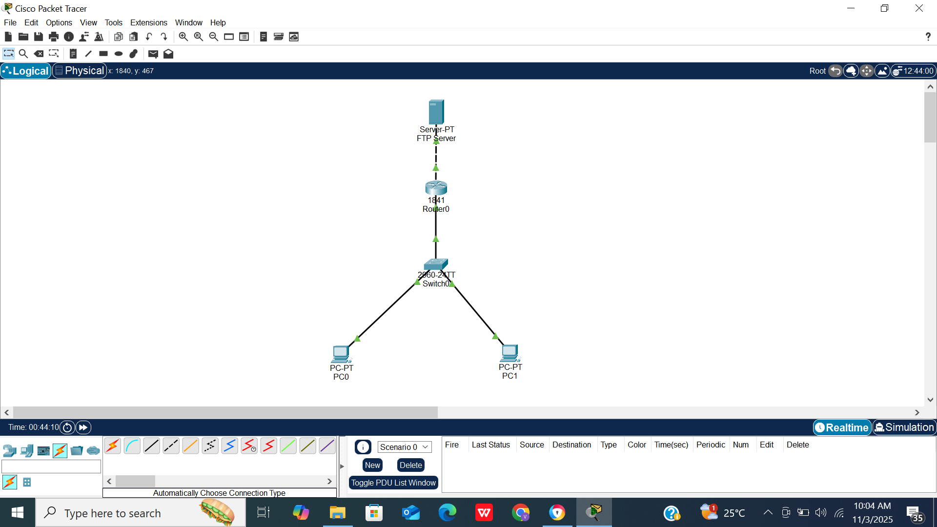

1. Configure the FTP Server
1. Click on the Server icon.
- Go to the Config tab → click FastEthernet0.
- Set the IP address and subnet mask (example):
IP Address: 192.168.1.1
Subnet Mask: 255.255.255.0
- Then go to the Services tab → click FTP.
- Turn FTP Service: ON.
- Add user accounts (example):
- Username: user1
Password: 1234
- Username: user2
Password: 5678
You can also add files for the users to access (e.g., “project.txt”).

2. Configure Router
1. Click on Router0 → Config tab → FastEthernet0/0.
Set:
IP Address: 192.168.1.254
Subnet Mask: 255.255.255.0
- Turn the interface ON.
- Go to FastEthernet0/1 (if connecting another network) and assign another network if needed.

3. Configure Switch
No IP needed unless you’re managing the switch.
Ensure cables are connected correctly (use copper straight-through).

4. Configure PCs
For PC0 and PC1:
- Click on each PC → Config tab → FastEthernet0.
- Set:
IP Address: 192.168.1.2 (for PC0)
Subnet Mask: 255.255.255.0
Default Gateway: 192.168.1.254

IP Address: 192.168.1.3 (for PC1)
Subnet Mask: 255.255.255.0
Default Gateway: 192.168.1.254

5. Test FTP Connection
1. Go to PC0 → Desktop → Command Prompt.
- Type:
ftp 192.168.1.1
- When prompted:
- Username: user1Password: 1234
You’ll see:
230 User logged in.
ftp>
- You can now upload/download files using:
get filename
put filename

Verification Commands
You can test connectivity before FTP login:
ping 192.168.1.1
If successful, FTP service will work.
FTP Server Command Prompt Coding part
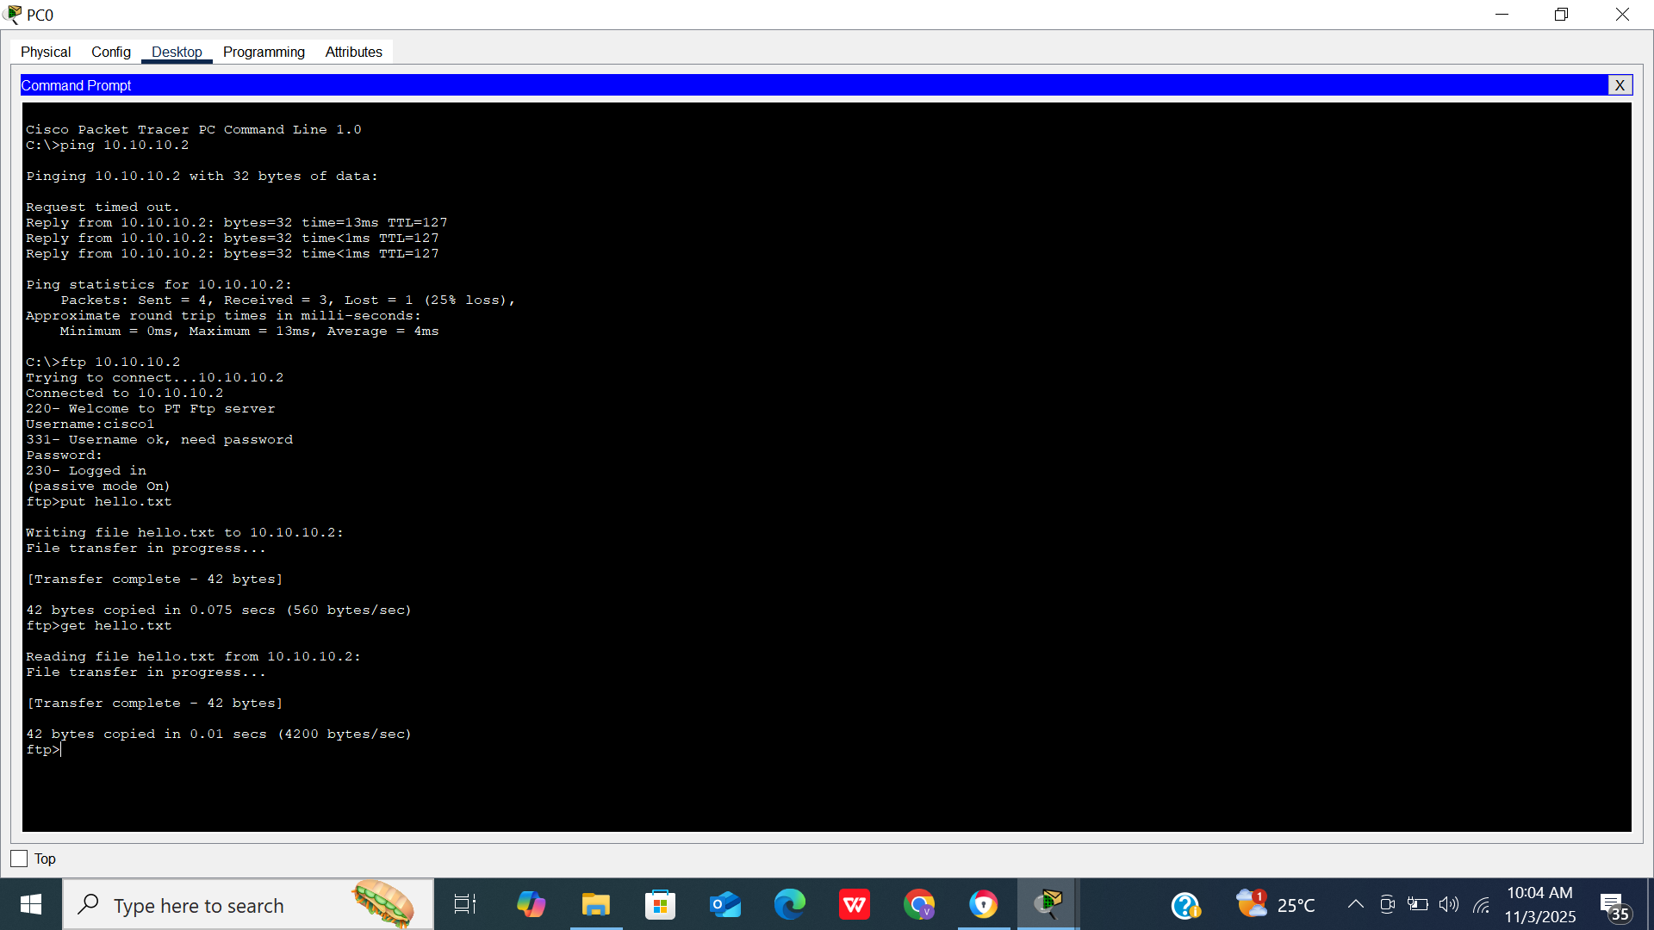
Conclusion - In this practical, I successfully configured an FTP server in Cisco Packet Tracer, enabling file transfer between client PCs and the server through the router and switch. This helped me understand how network devices communicate and how FTP services function for data sharing across a network.

